Microservices Containerization Assessment
Project Overview
This project demonstrates containerization of Node.js microservices using Docker and Docker Compose.
The application contains the following services:
- User Service
- Product Service
- Order Service
- Gateway Service
Each service runs inside its own Docker container and communicates through a shared Docker network.

Project Structure
Microservices-Task/
│
├── Microservices/
│ ├── user-service/
│ │ └── Dockerfile
│ │
│ ├── product-service/
│ │ └── Dockerfile
│ │
│ ├── order-service/
│ │ └── Dockerfile
│ │
│ └── gateway-service/
│ └── Dockerfile
│
├── docker-compose.yml
└── README.md

Prerequisites
The following software must be installed:
- Docker
- Docker Compose
- Git

Setup Instructions
Step 1: Clone Repository
git clone https://github.com/thupeshkumar/Microservices-Task.git
cd Microservices-Task
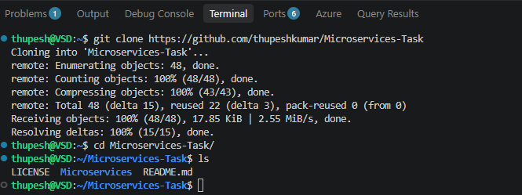
Step 2: Install Docker on Docker Desktop and Instance Screenshots
* Executing task: docker compose -f 'Microservices-Task/Microservices/docker-compose.yml' up -d --build

[+] Building 6.5s (40/40) FINISHED
=> [internal] load local bake definitions 0.0s
=> => reading from stdin 2.21kB 0.0s
=> [product-service internal] load build definition from Dockerfile 0.2s
=> => transferring dockerfile: 151B 0.1s
=> [user-service internal] load build definition from Dockerfile 0.2s
=> => transferring dockerfile: 151B 0.0s
=> [order-service internal] load build definition from Dockerfile 0.2s
=> => transferring dockerfile: 151B 0.1s
=> [gateway-service internal] load build definition from Dockerfile 0.2s
=> => transferring dockerfile: 158B 0.1s
=> [order-service internal] load metadata for docker.io/library/node:24-alpine 2.4s
=> [gateway-service internal] load metadata for docker.io/library/node:24-bookworm-slim 2.4s
=> [auth] library/node:pull token for registry-1.docker.io 0.0s
=> [gateway-service internal] load .dockerignore 0.1s
=> => transferring context: 2B 0.0s
=> [order-service internal] load .dockerignore 0.1s
=> => transferring context: 2B 0.0s
=> [product-service internal] load .dockerignore 0.1s
=> => transferring context: 2B 0.0s
=> [user-service internal] load .dockerignore 0.1s
=> => transferring context: 2B 0.0s
=> [gateway-service 1/5] FROM docker.io/library/node:24-bookworm-slim@sha256:ba849c60be29959425b8734d57b8b4b7d56f98edd9504c9af091d5281095a71e 0.2s
=> => resolve docker.io/library/node:24-bookworm-slim@sha256:ba849c60be29959425b8734d57b8b4b7d56f98edd9504c9af091d5281095a71e 0.1s
=> [user-service 1/5] FROM docker.io/library/node:24-alpine@sha256:e67514e5d0f6c46656005e1b693b2ec9d52e80b641307de684d4a015ba7a4eaf 0.2s
=> => resolve docker.io/library/node:24-alpine@sha256:e67514e5d0f6c46656005e1b693b2ec9d52e80b641307de684d4a015ba7a4eaf 0.1s
=> [product-service internal] load build context 0.1s
=> => transferring context: 89B 0.0s
=> [gateway-service internal] load build context 0.1s
=> => transferring context: 89B 0.0s
=> [order-service internal] load build context 0.1s
=> => transferring context: 89B 0.0s
=> [user-service internal] load build context 0.1s
=> => transferring context: 89B 0.0s
=> CACHED [user-service 2/5] WORKDIR /app 0.0s
=> CACHED [product-service 3/5] COPY package*.json ./ 0.0s
=> CACHED [product-service 4/5] RUN npm install 0.0s
=> CACHED [product-service 5/5] COPY . . 0.0s
=> CACHED [order-service 3/5] COPY package*.json ./ 0.0s
=> CACHED [order-service 4/5] RUN npm install 0.0s
=> CACHED [order-service 5/5] COPY . . 0.0s
=> CACHED [gateway-service 2/5] WORKDIR /app 0.0s
=> CACHED [gateway-service 3/5] COPY package*.json ./ 0.0s
=> CACHED [gateway-service 4/5] RUN npm install 0.0s
=> CACHED [gateway-service 5/5] COPY . . 0.0s
=> CACHED [user-service 3/5] COPY package*.json ./ 0.0s
=> CACHED [user-service 4/5] RUN npm install 0.0s
=> CACHED [user-service 5/5] COPY . . 0.0s
=> [product-service] exporting to image 0.9s
=> => exporting layers 0.0s
=> => exporting manifest sha256:9061865b336c3ba4963abbd9d5de04f79719e6fc289f1a200a4395b292725619 0.0s
=> => exporting config sha256:f0cf9dac83758185f2f868513da52aaabc543c65497b7046bb1cf1bb1466a7c1 0.0s
=> => exporting attestation manifest sha256:3c45f625bff2671906ce5c43bd857a1bef17e65428a9a01aa9760d213886a6e0 0.2s
=> => exporting manifest list sha256:80d5df089565dd13dd730944abeb3505761d35d254e261b198d9ce465ef9d06e 0.2s
=> => naming to docker.io/library/microservices-product-service:latest 0.0s
=> => unpacking to docker.io/library/microservices-product-service:latest 0.1s
=> [order-service] exporting to image 0.8s
=> => exporting layers 0.0s
=> => exporting manifest sha256:f2ceda07a011178e742d02aa250fdef88c9ac5d0add6eaae05c546b16819d9a5 0.0s
=> => exporting config sha256:ee918710975c44fe0376e7cd9acc19692e745195c83e8534e935aafe8bc544a5 0.0s
=> => exporting attestation manifest sha256:aed7c2b0e77596b84bdda630747990afdc17ea914f653ab7f37d1399934621cb 0.2s
=> => exporting manifest list sha256:c27ae2af81044f8b283d2cc17465ec8223c50980660c0daf7d6c5121498e27a2 0.2s
=> => naming to docker.io/library/microservices-order-service:latest 0.1s
=> => unpacking to docker.io/library/microservices-order-service:latest 0.0s
=> [user-service] exporting to image 0.8s
=> => exporting layers 0.0s
=> => exporting manifest sha256:faee4f670bceac985fd5ef517e310e462bc169dbf98d8702446fe7781023e878 0.0s
=> => exporting config sha256:5b66a07abeb75e1bee06b08410923501f2163d3bbba8a4be32962f4943047b64 0.0s
=> => exporting attestation manifest sha256:fe130fa56070ee6a93b2d1721e8aa46d7bd35939353f45df4b2ab0cea6de4df2 0.2s
=> => exporting manifest list sha256:570fcaa266de801519270a55cf9ceb95e8bd383ffb4834fc0a8e574faacc69c3 0.2s
=> => naming to docker.io/library/microservices-user-service:latest 0.0s
=> => unpacking to docker.io/library/microservices-user-service:latest 0.1s
=> [gateway-service] exporting to image 0.8s
=> => exporting layers 0.0s
=> => exporting manifest sha256:d899f002b782639a00dd49a217202ba86eefa437b06c5d6af58e7bb3ceea76b3 0.0s
=> => exporting config sha256:e60e0154051fff186672aa2445b17ef7b1180a7a849366b2499489e8c0224643 0.0s
=> => exporting attestation manifest sha256:ef9a1f0f6d6f5a17f8dd0e8afa7f56f4f3d80edcbef70c617d6536b39baf927a 0.2s
=> => exporting manifest list sha256:20a7f5c6323fa5b25fd45845a0a3b49c22819949776564a05d9d38cf447fd387 0.2s
=> => naming to docker.io/library/microservices-gateway-service:latest 0.0s
=> => unpacking to docker.io/library/microservices-gateway-service:latest 0.1s
=> [user-service] resolving provenance for metadata file 0.5s
=> [order-service] resolving provenance for metadata file 0.5s
=> [gateway-service] resolving provenance for metadata file 0.2s
=> [product-service] resolving provenance for metadata file 0.0s
[+] up 9/9
✔ Image microservices-gateway-service Built 7.2s
✔ Image microservices-user-service Built 7.2s
✔ Image microservices-product-service Built 7.2s
✔ Image microservices-order-service Built 7.2s
✔ Network microservices_microservices-network Created 0.2s
✔ Container user-service Started 2.9s
✔ Container product-service Started 2.8s
✔ Container gateway-service Started 2.7s
✔ Container order-service Started 3.0s
* Terminal will be reused by tasks, press any key to close it.

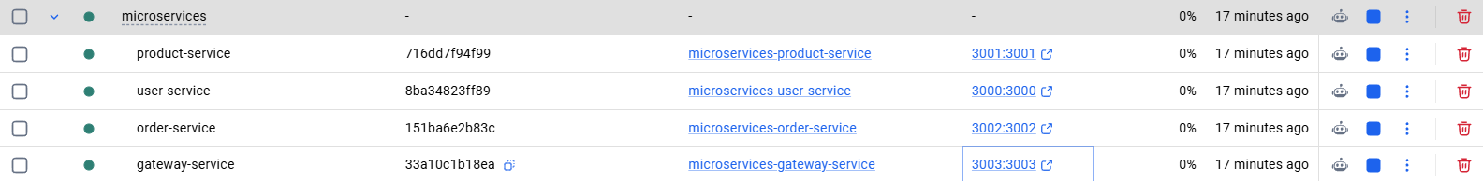
Services and Ports
Service | Port
User Service | 3000
Product Service | 3001
Order Service | 3002
Gateway Service | 3003

API Testing
User Service
Get Users
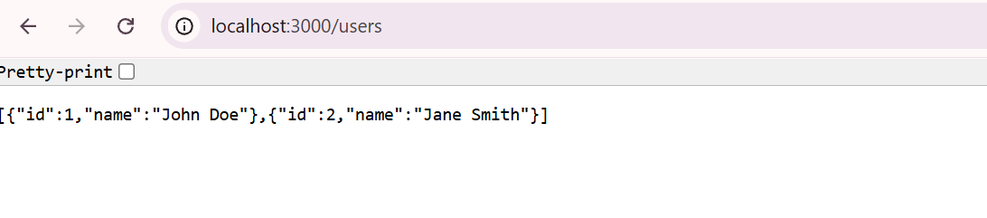
Product Service
Get Products
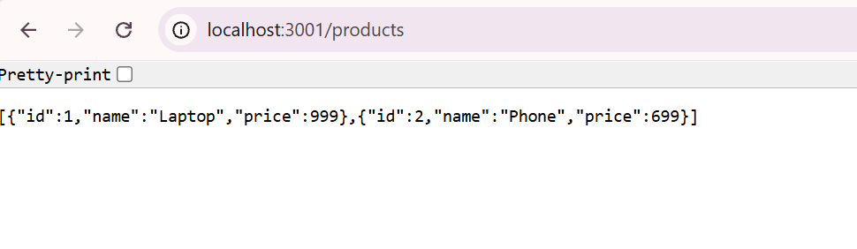
Order Service
Get Orders
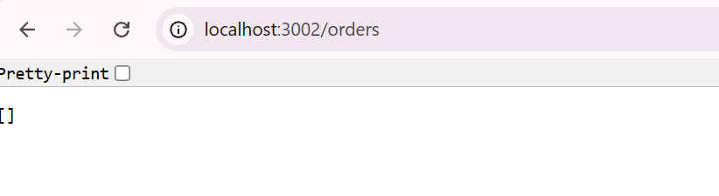
Gateway Service
Get Users via Gateway
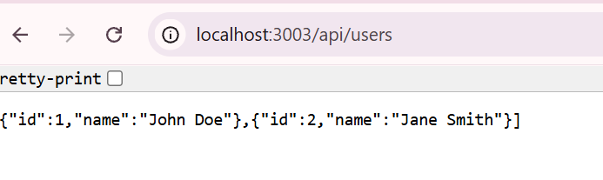
Get Products via Gateway
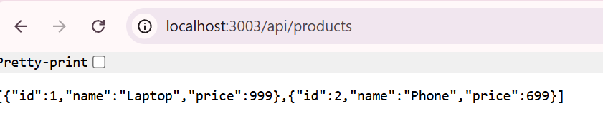
Get Orders via Gateway
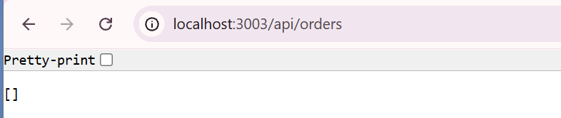

Docker Compose Configuration
The application uses Docker Compose for:
- Multi-container orchestration
- Shared networking
- Port mapping
- Service dependency management
- Troubleshooting
- Port Already in Use
- Check running containers:
- docker ps
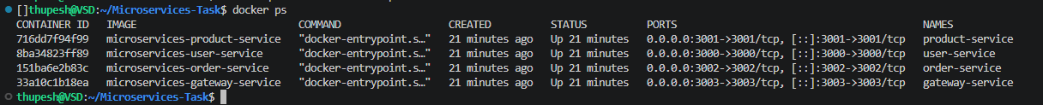
- Stop containers if necessary:
- docker compose down

- Docker Logs
- Check service logs:
- docker logs user-service
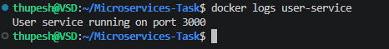
Conclusion
All microservices were successfully containerized using Docker and orchestrated using Docker Compose. The services communicate over a shared Docker network and are accessible through their respective ports.

